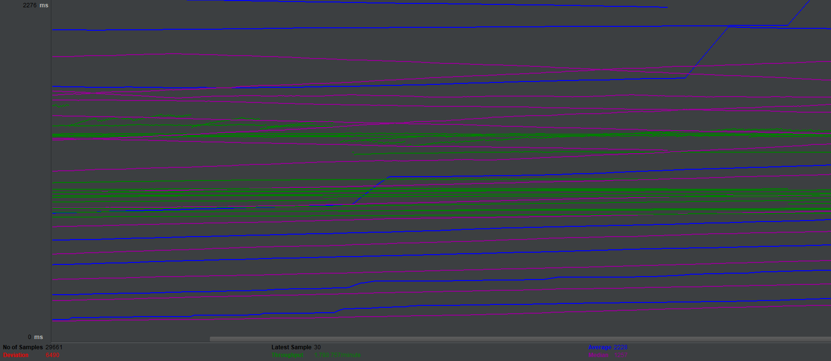

Sync

Synchronous call to database is the slowest operation in the systems. It blocks main thread, so web server can`t handle other requests while it`s waiting for database answer, so it leads to loss of performance. As a result, we can see throughput 1,780.757 per minute and 2228ms for response.

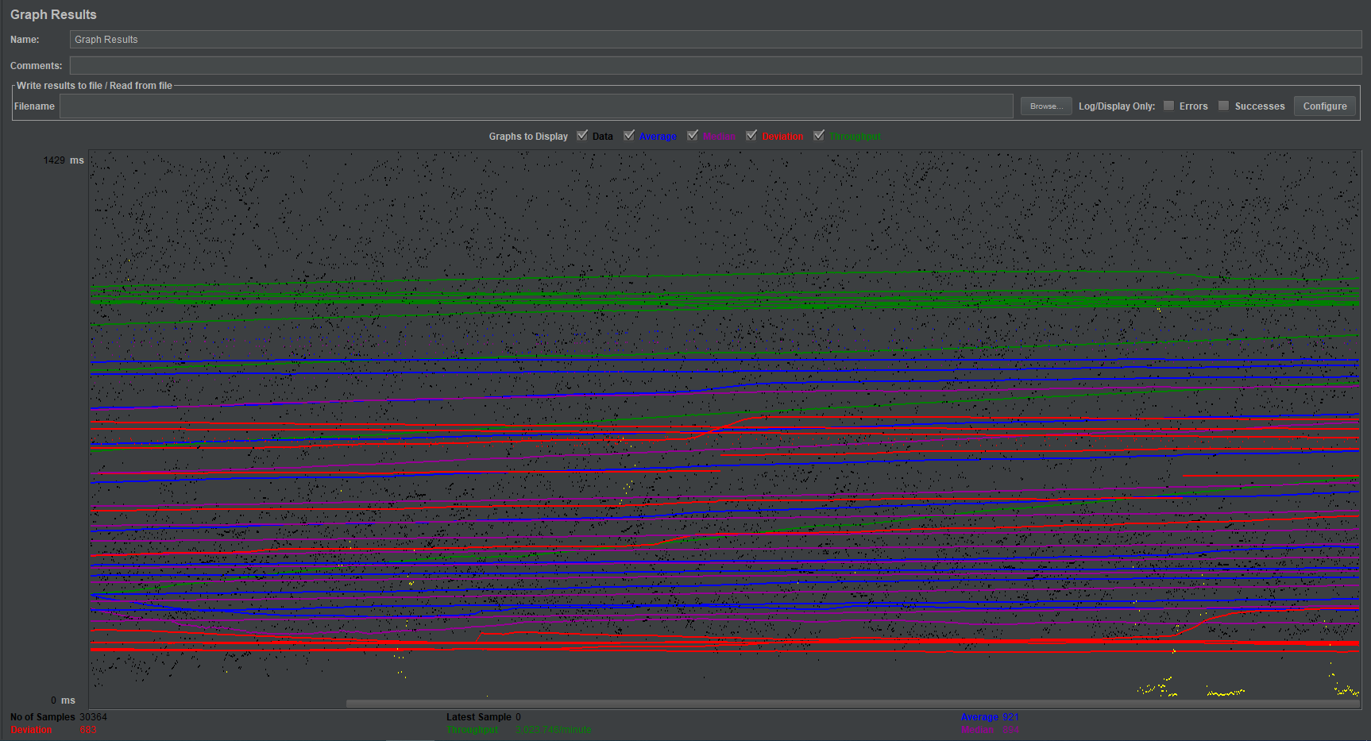

Async

Asynchronous call don`t block main thread while it`s waiting for database answer, so you can see 2 times performance increase. As a result, we can see throughput 3,023.746 per minute and 921ms for response.

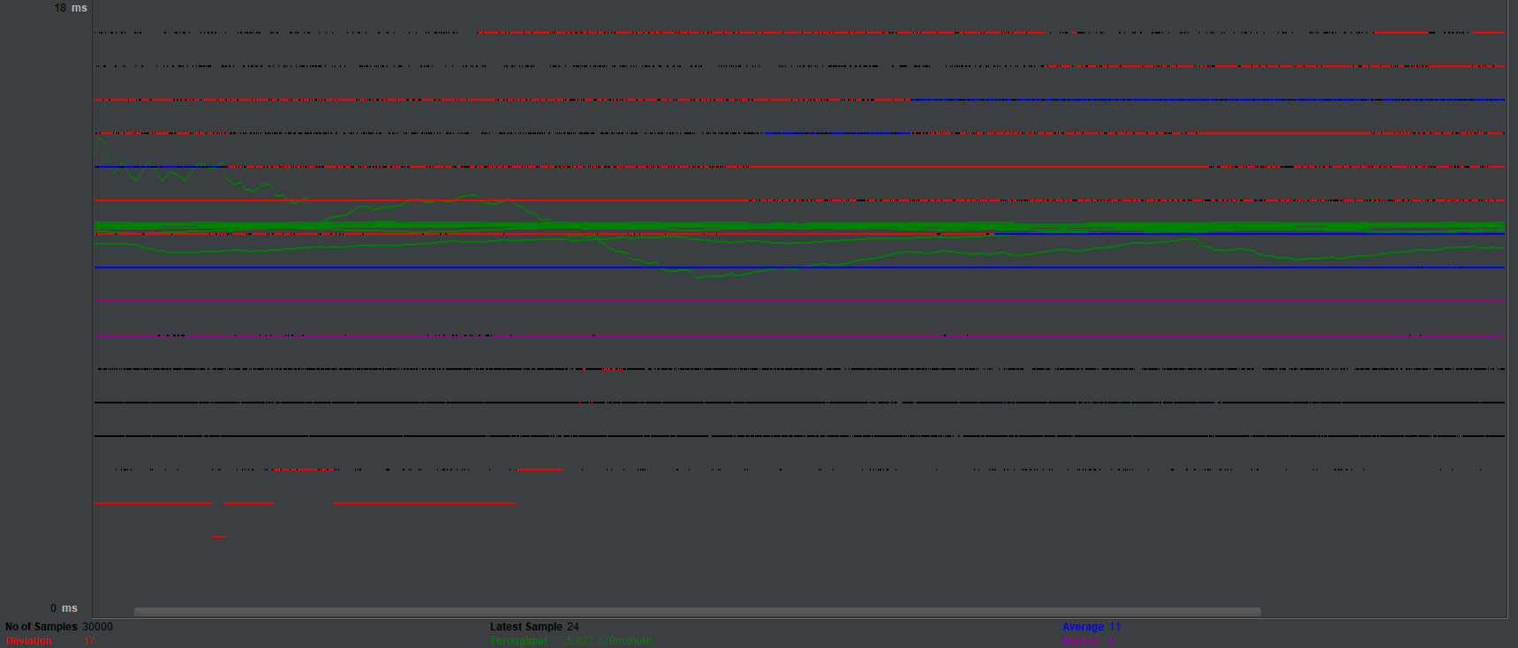

Middleware

Usage of asynchronous middleware is the fastest way to get the response and short-circuit the further execution. As a result, we can see throughput 5,827.279 per minute and 11ms for response.